CROSS FARM SCHOOL
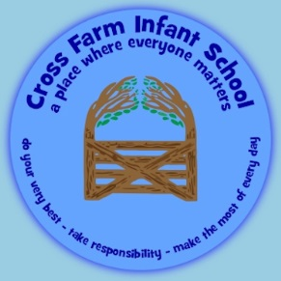

SPECIAL DIET REQUEST FORM

School ……………………………………………………………………………..

Child’s Name ……………………………………………………………………… Class: ……………………........ Please specify type of diet requested:
Medical (e.g. Nut/Gluten Allergy) ………………………………………………………………………………..

Religious (e.g. Halal, Hindu) ………………………………………………….......................................

Ethical (e.g. vegetarian = eats no meat or fish) ……………………………………................................................ Please print specific details. Identify food that the child is / is not allowed to eat.
Non Suitable Foods | Suitable or Substitute Foods

DOES YOUR CHILD HAVE A SIGNIFICANT OR LIFE THREATENING FOOD ALLERGY? (PLEASE CIRCLE) YES NO

The following is required for medical diets only and should be copied by the school representative (who signs below) from the pupil’s Care and Treatment Plan. N.B. This is essential to avoid misinterpretation.
EMERGENCY PROCEDURES FOR USE OF A PRELOADED ADRENALIN INJECTION  WHERE IS THE PRELOADED ADRENALIN INJECTION LOCATED?  ADMINISTERED BY WHOM? | Details: (school to complete)
LOCAL ARRANGEMENTS FOR IDENTIFICATION OF CHILD AGREED AND EMERGENCY PROCEDURE IN PLACE | Details: (school to complete)

Signature: …………………………………. Print Name: ………………………… Date: …………………………
Parent Parent

Signature: …………………………………. Print Name: ………………………… Date: …………………………
School Representative School Representative

Signature: …………………………………. Print Name: …………………………
Unit Caterer Unit Caterer Date ………………………….

This form should be held with the child’s Care and Treatment Plan within the school office and a copy passed to the Surrey Commercial Services Caterer

Termly Review Record

Date of review meeting | Signature of school representative | Signature of SCS Caterer | Comments

